IELTS

Writing

ACTIVITIES

ACTIVITY A01

You should spend about 20 minutes on this task

**The two pie charts below show the percentages of industry sectors' contribution to the economy of Turkey in 2000 and 2020.**

Summarise the information by selecting and reporting the main features making comparisons where relevant.

Write at least 150 words.

**Contribution to the economy of Turkey by sector**

ACTIVITY A02

You should spend about 20 minutes on this task

**The pie charts below show the devices people in the 18 to 25 age group use to watch television in**

**Canada in two different years.**

Summarise the information by selecting and reporting the main features making comparisons where relevant.

Write at least 150 words.

ACTIVITY A03

You should spend about 20 minutes on this task

**The charts below show the percentage of water used for different purposes in six areas of the world.**

Summarise the information by selecting and reporting the main features making comparisons where relevant.

Write at least 150 words.

|  |  |  |  |  |  |
| --- | --- | --- | --- | --- | --- |
|  | Agricultural Use |  | Domestic Use |  | Industrial Use |

ACTIVITY A04

You should spend about 20 minutes on this task

**The charts below show the reasons why people travel to work by bicycle or by car.**

Summarise the information by selecting and reporting the main features making comparisons where relevant.

Write at least 150 words.

ACTIVITY A05

You should spend about 20 minutes on this task

**The chart below shows the total number of minutes (in billions) of telephone call in the UK, divided into three categories, from 1995-2002.**

Summarise the information by selecting and reporting the main features making comparisons where relevant.

Write at least 150 words.

ACTIVITY A06

You should spend about 20 minutes on this task

**The chart below shows the percentage of male and female teachers in six different types of educational setting in the UK in 2010.**

Summarise the information by selecting and reporting the main features making comparisons where relevant.

Write at least 150 words.

ACTIVITY A07

You should spend about 20 minutes on this task

**The line graph below gives information about the number of students studying Computer Science at a UK university between 2010 and 2012**

Summarise the information by selecting and reporting the main features making comparisons where relevant.

Write at least 150 words.

ACTIVITY A08

You should spend about 20 minutes on this task

**The bar chart provides information about how often people in the USA spent ate fast food from 2003 to 2013.**

Summarise the information by selecting and reporting the main features making comparisons where relevant.

Write at least 150 words.

ACTIVITY A09

You should spend about 20 minutes on this task

**The graph below shows the changes in food conception by Chinese people between 1985 and 2010**

Summarise the information by selecting and reporting the main features making comparisons where relevant.

Write at least 150 words.

ACTIVITY A10

You should spend about 20 minutes on this task

**The line graph shows the number of people affected by rift valley fever in three countries in 1915.**

Summarise the information by selecting and reporting the main features making comparisons where relevant.

Write at least 150 words.

ACTIVITY A11

You should spend about 20 minutes on this task

**The line graph below shows the monthly ridership of four separate transportation forms in a European metropolitan area between 1980 and 2030.**

Summarise the information by selecting and reporting the main features making comparisons where relevant.

Write at least 150 words.

ACTIVITY A12

You should spend about 20 minutes on this task

**The graph below shows the number of tourists visiting a particular Caribbean island between 2010 and 2017.**

Summarise the information by selecting and reporting the main features making comparisons where relevant.

Write at least 150 words.

ACTIVITY A13

You should spend about 20 minutes on this task

**The table shows data about underground railway system in Six major cities with data opened, kilometers of route and passenger number in million**

Summarise the information by selecting and reporting the main features making comparisons where relevant.

Write at least 150 words.

|  |  |  |  |
| --- | --- | --- | --- |
| **City** | **Date opened** | **Kilometer of route** | **Passengers per year (in million)** |
| London | 1863 | 394 | 775 |
| Paris | 1900 | 394 | 1191 |
| Tokyo | 1927 | 155 | 1928 |
| Washington DC | 1976 | 126 | 144 |
| Kyoto | 1981 | 11 | 45 |
| Los Angeles | 2001 | 28 | 50 |

ACTIVITY A14

You should spend about 20 minutes on this task

**The table below illustrates weekly consumption by age group of dairy products in a European country.**

Summarise the information by selecting and reporting the main features making comparisons where relevant.

Write at least 150 words.

|  |  |  |  |  |
| --- | --- | --- | --- | --- |
| **AGES** | | | | |
|  | **<25** | **26 – 45** | **45 – 65** | **65+** |
| Milk | 1200ml | 1650ml | 1670ml | 1900ml |
| Full Fat | 59% | 20% | 45% | 30% |
| Low Fat | 41% | 80% | 55% | 70% |
|  |  |  |  |  |
| Butter | 12g | 19g | 60g | 30g |
| Full Fat | 60% | 38% | 50% | 49% |
| Low Fat | 40% | 62% | 50% | 51% |

ACTIVITY A15

You should spend about 20 minutes on this task

**The following table gives statistics showing the aspects of quality of life in five countries.**

Summarise the information by selecting and reporting the main features making comparisons where relevant.

Write at least 150 words.

The Quality of Life in Five Countries

|  |  |  |  |  |
| --- | --- | --- | --- | --- |
| Country | GNP per head (1982: US dollars) | Daily calorie supply per head | Life expectancy at birth (years) | Infant mortality  (per 1000 live births |
| Bangladesh Bolivia Egypt Indonesia USA | 140 570 690 580 13160 | 1877 2086 2950 2296 3653 | 40 50 56 49 74 | 132 124 97 87 12 |

ACTIVITY A16

You should spend about 20 minutes on this task

**The table shows the Proportions of Pupils Attending Four Secondary School Types between 2000 and 2009.**

Summarise the information by selecting and reporting the main features making comparisons where relevant.

Write at least 150 words.

|  |  |  |  |
| --- | --- | --- | --- |
|  | **2000** | **2005** | **2009** |
| **Specialist Schools** | 12% | 11% | 10% |
| **Grammar Schools** | 24% | 19% | 12% |
| **Voluntary-controlled  Schools** | 52% | 38% | 20% |
| **Community Schools** | 12% | 32% | 58% |

ACTIVITY A17

You should spend about 20 minutes on this task

**The diagram below shows the manufacturing process for making sugar from sugar cane.**

Summarise the information by selecting and reporting the main features making comparisons where relevant.

Write at least 150 words.

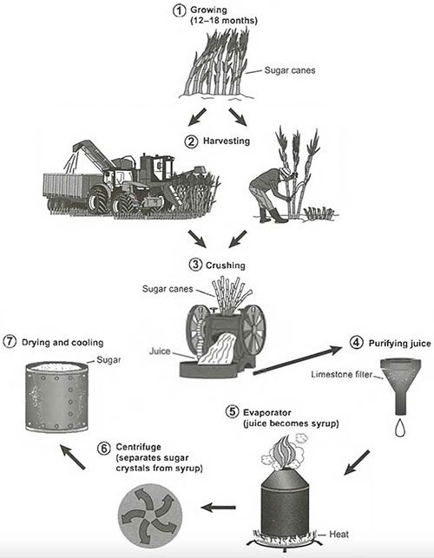

ACTIVITY A18

You should spend about 20 minutes on this task

**The illustrations show how chocolate is produced.**

Summarise the information by selecting and reporting the main features making comparisons where relevant.

Write at least 150 words.

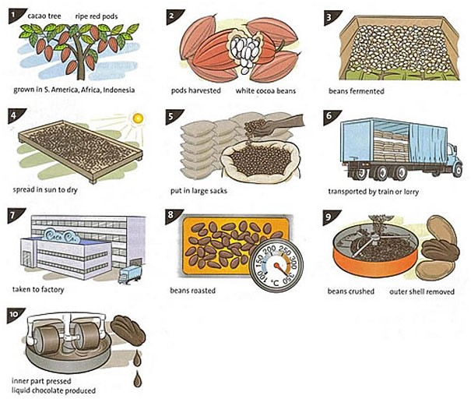

ACTIVITY A19

You should spend about 20 minutes on this task

**The diagram below shows the process of using water to generate electricity for human use.**

Summarise the information by selecting and reporting the main features making comparisons where relevant.

Write at least 150 words.

ACTIVITY A20

You should spend about 20 minutes on this task

**The maps show the developments which took place in the coastal of town Laguna Beach between 1950, 1970 and 1990.**

Summarise the information by selecting and reporting the main features making comparisons where relevant.

Write at least 150 words.

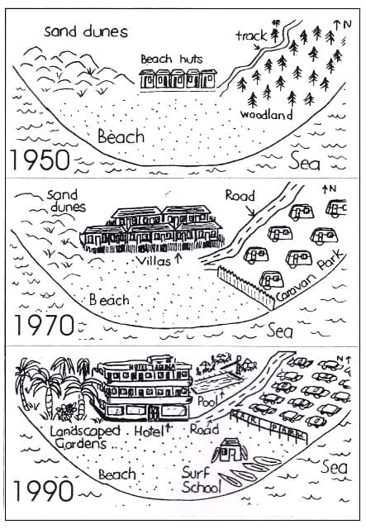

ACTIVITY A21

You should spend about 20 minutes on this task

**The plans below show the layout of a university's sports centre now, and how it will look after redevelopment.**

Summarise the information by selecting and reporting the main features making comparisons where relevant.

Write at least 150 words.

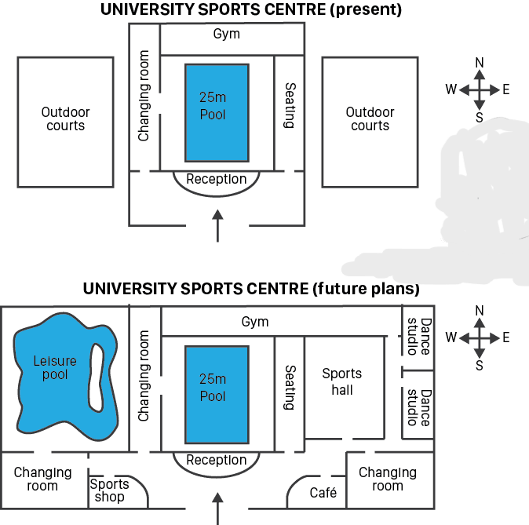

ACTIVITY A22

You should spend about 20 minutes on this task

**The two maps below show the changes in town of Denham from 1986 to the present day.** Summarise the information by selecting and reporting the main features making comparisons where relevant.

Write at least 150 words.

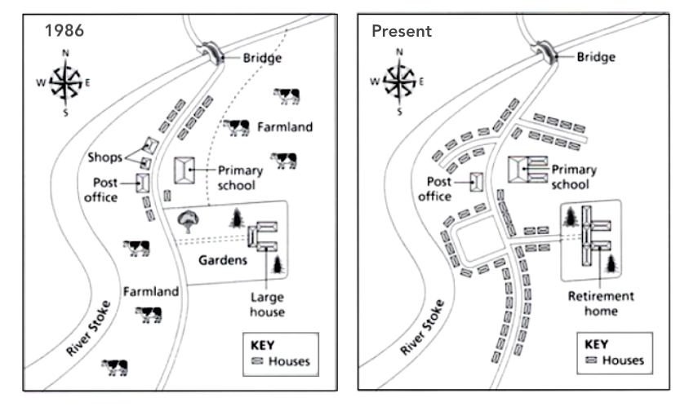

**IELTS GENERAL ACTIVITIES**

ACTIVITY G01

You should spend about 20 minutes on this task

You have recently moved to a different house. Write a letter to an English-speaking friend. In your letter,

* explain why you have moved
* describe the new house
* invite your friend to come and visit

Write at least 150 words.

You do not need to write any addresses.

Begin your letter as follows;

Dear …………,

ACTIVITY G02

You should spend about 20 minutes on this task

You have just missed a friend’s party. Write a letter to apologise. In your letter:

* apologise to your friend
* explain why you did not attend the party
* say what you plan to do to make up for missing the party.

Write at least 150 words.

You do not need to write any addresses.

Begin your letter as follows;

Dear …………,

ACTIVITY G03

You should spend about 20 minutes on this task

A family member is coming to stay with you. He/she will be arriving by train in the morning, but you won’t be home until the evening. Write a letter to your relative. In your letter:

* explain arrangements you have made for them to have keys and get into the house
* tell your relative how to get from the train station to your house
* say when you will be home and suggest what you could do together that evening.

Write at least 150 words.

You do not need to write any addresses.

Begin your letter as follows;

Dear …………,

ACTIVITY G04

You should spend about 20 minutes on this task

Your friends recently moved to a new city. You will also be moving to the same city. Write a letter to your friends and include:

* Ask where to find a place to live
* Tell them what type of place you’re looking for
* Share some fun things you would like to do when you get there

Write at least 150 words.

You do not need to write any addresses.

Begin your letter as follows;

Dear …………,

ACTIVITY G05

You should spend about 20 minutes on this task

You are due to move into a rented apartment next week but you will not be able to due to an unexpected problem. Write a letter to the property manager. In your letter

* + - Explain the situation
    - Describe your problems
    - Tell him/her when you think you can move in

Write at least 150 words.

You do not need to write any addresses.

Begin your letter as follows:

Dear Ms. Williams,

ACTIVITY G06

You should spend about 20 minutes on this task

You have been living in a rental apartment for the past year. Recently, a new neighbour moved in who has loud parties several times a week. Write a letter to your landlord. In your letter:

* + - Explain the situation
    - Describe why it bothers you
    - Suggest a solution

Write at least 150 words.

You do not need to write any addresses.

Begin your letter as follows:

Dear Mr. Ronch,

ACTIVITY G07

You should spend about 20 minutes on this task

You are organising a trip to a major city in your country, for a group of students from your university. Write to the Tour Manager, Mr Abraham, of an organization that organizes trips. In your letter, explain:

* when you want to visit and how long you will stay
* how many students are in your group
* and what accommodation you will require

Write at least 150 words.

You do not need to write any addresses.

Begin your letter as follows;

Dear …………,

ACTIVITY G08

You should spend about 20 minutes on this task

You are a member of an International Students' club. The club is organising an event to celebrate popular food from around the world. Write a letter to the event organiser, Luis. In your letter,

* offer to make a popular dish from your country
* describe what this dish is explain
* why it should be included in the event

Write at least 150 words.

You do not need to write any addresses.

Begin your letter as follows;

Dear Luis,

ACTIVITY G09

You should spend about 20 minutes on this task

# You would like to reduce your working hours in order to study part time. Write a letter to your boss. In your letter

# explain why you want to reduce your working hours

# say which hours you would like to work

# describe how your part-time studies would benefit your employer

Write at least 150 words.

You do not need to write any addresses.

Begin your letter as follows;

Dear ________,

ACTIVITY G10

You should spend about 20 minutes on this task

You started in your present job two years ago. You now feel it is important for your career development to move to a different department in the same company. Write a letter to your manager. In your letter;

* say what you have learned in your present job
* suggest how the company would benefit from moving you to a different department
* explain why you do not wish to leave the company

Write at least 150 words.

You do not need to write any addresses.

Begin your letter as follows;

Dear ________,

ACTIVITY G11

You should spend about 20 minutes on this task.

Your car insurance company has told you that they are going to increase the amount you have to pay in insurance for your car each month. You are not happy about this. Write a letter to your insurance company. In your letter explain;

* Why you are writing to them
* Why you think the insurance should not be increased
* What you want them to do

Write at least 150 words.

You do not need to write any addresses.

Begin your letter as follows;

Dear …………,

ACTIVITY G12

You should spend about 20 minutes on this task

You and your friends ate a meal at a restaurant to celebrate a special occasion, and you were extremely dissatisfied with the experience. Write a letter to the restaurant manager. In your letter:

* Explain the reason for the celebration
* Give details of your visit to the restaurant
* Say what you would like the restaurant to do

Write at least 150 words.

You do not need to write any addresses.

Begin your letter as follows;

Dear …………,

ACTIVITY G13

You should spend about 20 minutes on this task

The system used for rubbish/garbage collection in your local area is not working properly. This is causing problems for you and your neighbours. Write a letter to the local council. In your letter:

* describe how the rubbish collection system is not working properly
* explain how this is affecting you and your neighbours
* suggest what should be done about the problem

Write at least 150 words.

You do not need to write any addresses.

Begin your letter as follows;

Dear …………,

ACTIVITY G014

You should spend about 20 minutes on this task

You decided to drive a bicycle to work and do not have parking space available. Write a letter to the build manager: in your letter;

* Why did you decide to use a bicycle?
* What is the problem?
* Provide some suggestions.

Write at least 150 words.

You do not need to write any addresses.

Begin your letter as follows;

Dear …………,

ACTIVITY G15

You should spend about 20 minutes on this task

### You recently had your computer fixed at a local computer store, however, you are not pleased with the service you received. **Write a letter to the store manager. In the letter;**

* describe the situation
* explain why you are dissatisfied
* say what you want the manager to do

Write at least 150 words.

You do not need to write any addresses.

Begin your letter as follows;

Dear …………,

ACTIVITY E01

Write about the following topic:

You should spend about 40 minutes on this task.

# **Today more people are overweight than ever before.**

**What in your opinion are the primary causes of this?**

**What measures can be taken to overcome this epidemic?**

Give reasons for your answer and include any relevant examples from your own knowledge or experience.

Write at least 250 words.

ACTIVITY E02

Write about the following topic:

You should spend about 40 minutes on this task.

**More and more people today are drinking sugar-based drinks.**

**What are the reasons for this?**

**What are the solutions to make people drink less?**

Give reasons for your answer and include any relevant examples from your own knowledge or experience.

Write at least 250 words.

ACTIVITY E03

Write about the following topic:

You should spend about 40 minutes on this task.

**Some people think that it is necessary to travel abroad to learn about other countries, but other people think that it is not necessary to travel abroad because all the information can be seen at TV and the Internet.**

**Discuss both views and give your opinion.**

Give reasons for your answer and include any relevant examples from your own knowledge or experience.

Write at least 250 words.

ACTIVITY E04

Write about the following topic:

You should spend about 40 minutes on this task.

**Some people think that competition at work, at school and in daily life is a good thing. Others believe that we should try to cooperate more, rather than competing against each other.**

**Discuss both these views and give your own opinion.**

Give reasons for your answer and include any relevant examples from your own knowledge or experience.

Write at least 250 words.

ACTIVITY E05

Write about the following topic:

You should spend about 40 minutes on this task.

**More and more people are moving from the countryside to the city.**

**What are some of the problems this can cause?**

**What solutions can you suggest?**

Give reasons for your answer and include any relevant examples from your own knowledge or experience.

Write at least 250 words.

ACTIVITY E06

Write about the following topic:

You should spend about 40 minutes on this task.

**Overpopulation of urban areas has led to numerous problems.**

**Identify some of the problems this can cause?**

**Suggest ways that governments and individuals can tackle these problems.**

Give reasons for your answer and include any relevant examples from your own knowledge or experience.

Write at least 250 words.

ACTIVITY E07

Write about the following topic:

You should spend about 40 minutes on this task.

**Some people think that social media platforms are useful for business and making new friends, while others think that such websites are harmful.**

**Discuss the advantages and disadvantages of social media.**

Give reasons for your answer and include any relevant examples from your own knowledge or experience.

Write at least 250 words.

ACTIVITY E08

Write about the following topic:

You should spend about 40 minutes on this task.

**It is important for people to take risks, both in their personal lives and professional lives.**

**Do you think the advantages of taking risk outweigh the disadvantages?**

Give reasons for your answer and include any relevant examples from your own knowledge or experience.

Write at least 250 words.

ACTIVITY E09

Write about the following topic:

You should spend about 40 minutes on this task.

Nowadays, more people would rather purchase food than cook at home.

What are the advantages and disadvantages of this trend?

Give reasons for your answer and include any relevant examples from your own knowledge or experience.

Write at least 250 words.

ACTIVITY E10

Write about the following topic:

You should spend about 40 minutes on this task.

**Big salary is much more important than job satisfaction.**

**Do you agree or disagree?**

Give reasons for your answer and include any relevant examples from your own knowledge or experience.

Write at least 250 words.

ACTIVITY E11

Write about the following topic:

You should spend about 40 minutes on this task.

**Money should be spent on creating new public buildings such as museums or town halls rather than renovating the existing ones.  
To what extent do you agree or disagree?**

Give reasons for your answer and include any relevant examples from your own knowledge or experience.

Write at least 250 words.

ACTIVITY E12

Write about the following topic:

You should spend about 40 minutes on this task.

**People today are suffering more and more stress related problems than in the past.**

**What is the cause of this?**

**What are the possible effects of this development?**

Give reasons for your answer and include any relevant examples from your own knowledge or experience.

Write at least 250 words.

ACTIVITY E13

Write about the following topic:

You should spend about 40 minutes on this task.

**Many criminals commit further crimes as soon as they are released from prison.**

**What do you think re the causes of this?**

**What effects will have on society?**

Give reasons for your answer and include any relevant examples from your own knowledge or experience.

Write at least 250 words.

ACTIVITY E14

Write about the following topic:

You should spend about 40 minutes on this task.

**It is sometimes possible to pay somebody to do things you don't want to do, or don't have time to do, for example, household chores or looking after children.**

**Is this a good way ofproviding work for others?**

**Should people do these things themselves?**

Give reasons for your answer and include any relevant examples from your own knowledge or experience.

Write at least 250 words.

ACTIVITY E15

Write about the following topic:

You should spend about 40 minutes on this task.

**Some consumers are increasingly choosing to buy goods that are produced in their local area, rather than imported goods.**

**What are the reasons for this?**

**Is this a positive or a negative trend?**

Give reasons for your answer and include any relevant examples from your own knowledge or experience.

Write at least 250 words.